**Priority Queue:]**

**Why?**

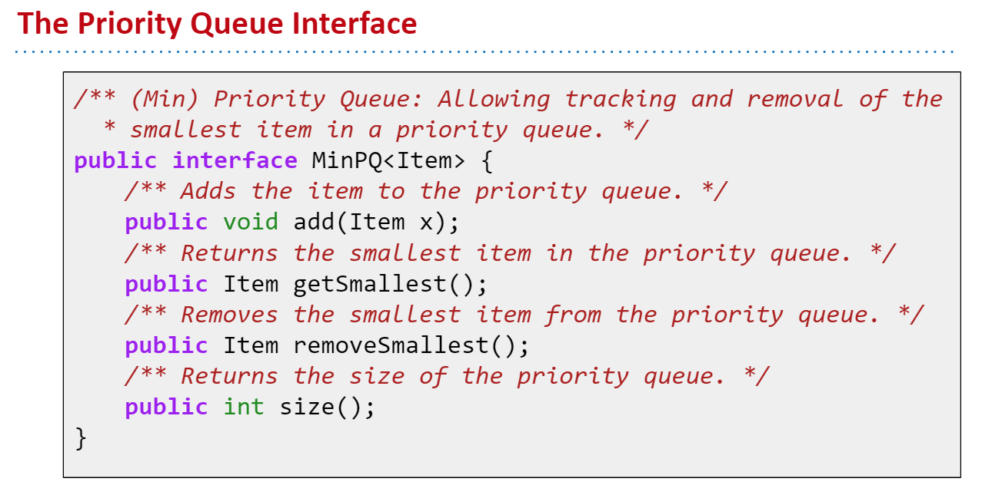

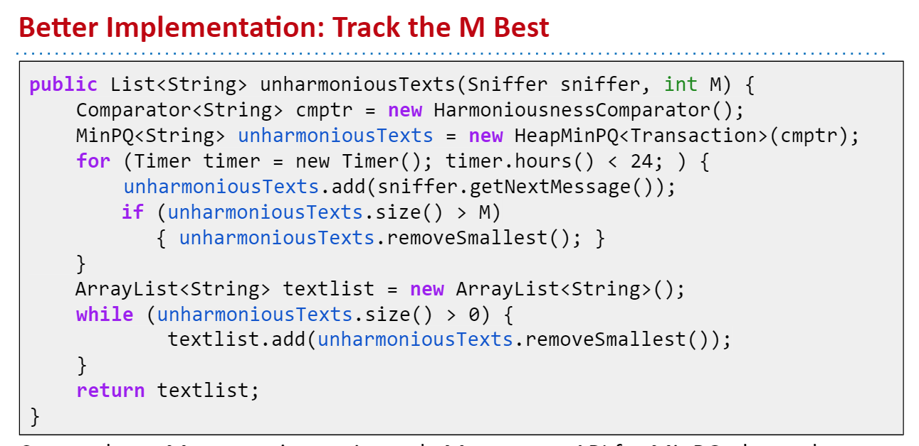

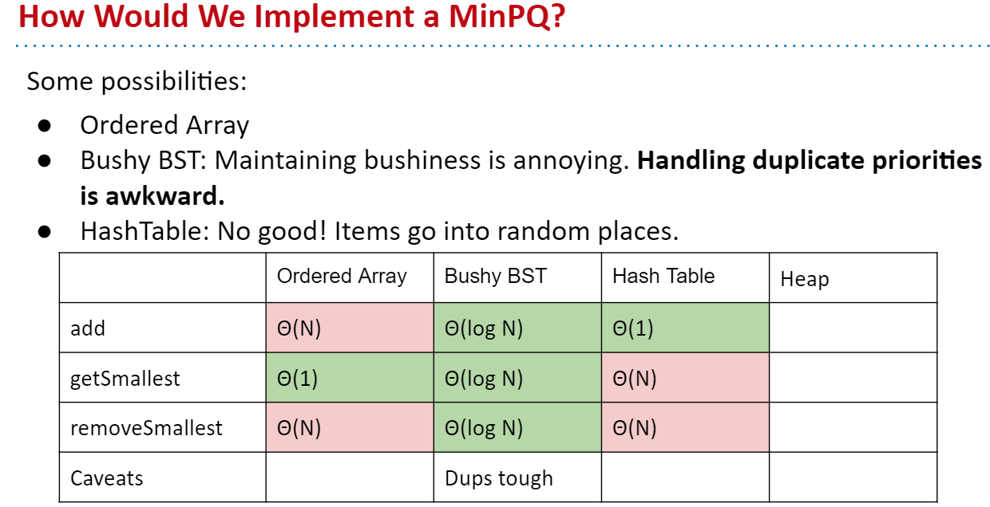

BSTs would work, but need to be kept bushy and duplicates are awkward.

Binary min-heap: Binary tree that is ***complete*** and obeys ***min-heap property***.

* Min-heap: Every node is less than or equal to both of its children.
* Complete: Missing items only at the bottom level (if any), all nodes are as far left as possible.

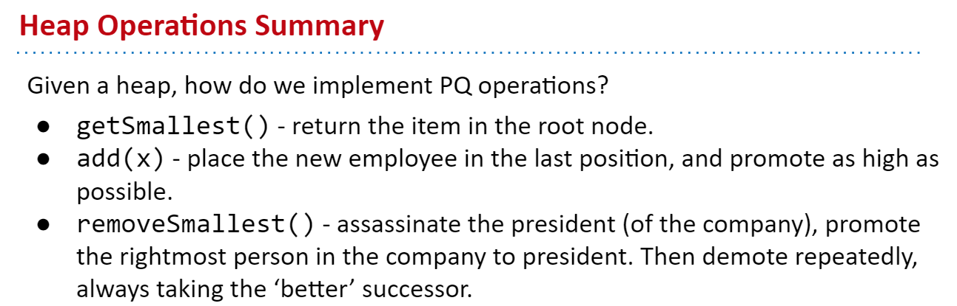

See <https://goo.gl/wBKdFQ> for an animated demo.

**Tree representation:**

